**Q.1) Write a c++ program to check prime number .**

**CODING**

**#include<iostream.h>**

**#include<conio.h>**

**int main()**

**{**

**clrscr();**

**int n, i, m=0, flag=0;**

**cout << "Enter the Number to check Prime: ";**

**cin >> n;**

**m=n/2;**

**for(i=2 ; i<= m ; i++)**

**{**

**if(n%i==0)**

**{**

**cout<<"Number is not Prime."<<endl;**

**flag=1;**

**break;**

**}**

**}**

**if (flag==0)**

**cout << "Number is Prime."<<endl;**

**getch();**

**}**

**FIRST OUTPUT**

**Enter the Number to check Prime: 17**

**Number is Prime.**

**SECOND OUTPUT**

**Enter the Number to check Prime: 4**

**Number is not Prime.**

**Q.2) Write a c++ program to check palindrome number.**

**CODING**

**#include<iostream.h>**

**#include<conio.h>**

**void main()**

**{**

**clrscr();**

**int n, num, digit, rev = 0;**

**cout << "Enter a positive number: ";**

**cin >> num;**

**n = num;**

**do**

**{**

**digit = num % 10;**

**rev = (rev * 10) + digit;**

**num = num / 10;**

**} while (num != 0);**

**cout << " The reverse of the number is: " << rev << endl;**

**if (n == rev)**

**cout << " The number is a palindrome.";**

**else**

**cout << " The number is not a palindrome.";**

**getch();**

**}**

**FIRST OUTPUT**

**Enter a positive number: 121**

**The reverse of the number is: 121**

**The number is a palindrome.**

**SECOND OUTPUT**

**Enter a positive number: 43**

**The reverse of the number is: 34**

**The number is not a palindrome.**

**Q.3) Write a c++ program to print factorial of a number .**

**CODING**

**#include<iostream.h>**

**#include<conio.h>**

**void main()**

**{**

**clrscr();**

**int num,factorial=1;**

**cout<<" Enter Number To Find Its Factorial: ";**

**cin>>num;**

**for(int a=1;a<=num;a++)**

**{**

**factorial=factorial*a;**

**}**

**cout<<"Factorial of Given Number is ="<<factorial<<endl;**

**getch();**

**}**

**OUTPUT**

**Enter Number To Find Its Factorial: 5**

**Factorial of Given Number is = 120**

**Q.4) Write a c++ program to print sum of digits.**

**CODING**

**#include<iostream.h>**

**#include<conio.h>**

**int main()**

**{**

**clrscr();**

**int val,num,sum=0;**

**cout<<"Enter the number : ";**

**cin>>val;**

**num = val;**

**while(num!=0)**

**{**

**sum = sum+num%10;**

**num = num/10;**

**}**

**cout <<"The sum of the digits of "<<val<<" is "<<sum;**

**getch();**

**}**

**OUTPUT**

**Enter the number : 1478**

**The sum of the digits of 1478 is 20**

**Q.5) Write a c++ program to reverse a given number.**

**CODING**

**#include<iostream.h>**

**#include<conio.h>**

**int main()**

**{**

**clrscr();**

**int n, reverse=0, rem;**

**cout<<"Enter a number : ";**

**cin>>n;**

**while(n!=0)**

**{**

**rem=n%10;**

**reverse=reverse*10+rem;**

**n/=10;**

**}**

**cout<<"Reversed Number : "<<reverse<<endl;**

**getch();**

**}**

**OUTPUT**

**Enter a number : 45**

**Reversed Number : 54**

**Q.6) Write a c++ program to swap two numbers using third variable.**

**CODING**

**#include<iostream.h>**

**#include<conio.h>**

**int main()**

**{**

**clrscr();**

**int a, b;**

**cout << "Enter two numbers to be swapped : ";**

**cin >> a >> b;**

**cout<<"Values before swap :\n";**

**cout<<"a = "<<a;**

**cout<<endl;**

**cout<<"b = "<<b;**

**b = a + b;**

**a = b - a;**

**b = b - a;**

**cout<<endl;**

**cout << "The two numbers after swapping become :" << endl;**

**cout << "Value of a : " << a << endl;**

**cout << "Value of b : " << b << endl;**

**getch();**

**}**

**OUTPUT**

**Enter two numbers to be swapped : 12**

**88**

**Values before swap :**

**a = 12**

**b = 88**

**The two numbers after swapping become :**

**Value of a : 88**

**Value of b : 12**

**Q.7) Write a c++ program to print multiplication of 2 matrices.**

**CODING**

**#include<iostream.h>**

**#include<conio.h>**

**int main()**

**{**

**clrscr();**

**int a[10][10],b[10][10],mul[10][10],r,c,i,j,k;**

**cout<<"Enter the number of row = ";**

**cin>>r;**

**cout<<"Enter the number of column = ";**

**cin>>c;**

**cout<<"Enter the first matrix element = \n";**

**for(i=0;i<r;i++)**

**{**

**for(j=0;j<c;j++)**

**{**

**cin>>a[i][j];**

**}**

**}**

**cout<<"Enter the second matrix element = \n";**

**for(i=0;i<r;i++)**

**{**

**for(j=0;j<c;j++)**

**{**

**cin>>b[i][j];**

**}**

**}**

**cout<<"Multiply of the matrix = \n";**

**for(i=0;i<r;i++)**

**{**

**for(j=0;j<c;j++)**

**{**

**mul[i][j]=0;**

**for(k=0;k<c;k++)**

**{**

**mul[i][j]+=a[i][k]*b[k][j];**

**}**

**}**

**}**

**for(i=0;i<r;i++)**

**{**

**for(j=0;j<c;j++)**

**{**

**cout<<mul[i][j]<<" ";**

**}**

**cout<<"\n";**

**}**

**getch();**

**}**

**OUTPUT**

**Enter the number of row = 2**

**Enter the number of column = 2**

**Enter the first matrix element =**

**1**

**2**

**3**

**4**

**Enter the second matrix element =**

**5**

**6**

**7**

**8**

**Multiply of the matrix =**

**19 22**

**43 50**

**Q.8) Write a c++ program to convert decimal number to binary.**

**CODING**

**#include<iostream.h>**

**#include<conio.h>**

**void main()**

**{**

**clrscr();**

**int a[10], n, i;**

**cout<<"Enter the number to convert : ";**

**cin>>n;**

**for(i=0; n>0; i++)**

**{**

**a[i]=n%2;**

**n= n/2;**

**}**

**cout<<"Binary of the given number = ";**

**for(i=i-1 ;i>=0 ;i--)**

**{**

**cout<<a[i];**

**}**

**getch();**

**}**

**OUTPUT**

**Enter the number to convert : 12**

**Binary of the given number = 1100**

**Q.9) Write a c++ program to print alphabet triangle.**

**CODING**

**#include<iostream.h>**

**#include<conio.h>**

**void main()**

**{**

**clrscr();**

**char ch='A';**

**int i, j, k, m;**

**for(i=1;i<=5;i++)**

**{**

**for(j=5;j>=i;j--)**

**cout<<" ";**

**for(k=1;k<=i;k++)**

**cout<<ch++;**

**ch--;**

**for(m=1;m<i;m++)**

**cout<<--ch;**

**cout<<"\n";**

**ch='A';**

**}**

**getch();**

**}**

**OUTPUT**

A

ABA

ABCBA

ABCDCBA

ABCDEDCBA

**Q.10) Write a c++ program to generate fibonacci triangle.**

**CODING**

**#include<iostream.h>**

**#include<conio.h>**

**int main()**

**{**

**clrscr();**

**int a=0,b=1,i,c,n,j;**

**cout<<"Enter the limit: ";**

**cin>>n;**

**for(i=1; i<=n; i++)**

**{**

**a=0;**

**b=1;**

**cout<<b<<"\t";**

**for(j=1; j<i; j++)**

**{**

**c=a+b;**

**cout<<c<<"\t";**

**a=b;**

**b=c;**

**}**

**cout<<"\n";**

**}**

**getch();**

**}**

**OUTPUT**

Enter the limit: 10

1

1 1

1 1 2

1 1 2 3

1 1 2 3 5

1 1 2 3 5 8

1 1 2 3 5 8 13

1 1 2 3 5 8 13 21

1 1 2 3 5 8 13 21 34

1 1 2 3 5 8 13 21 34 55

**Q. 11) create bio data and manipulating a text using MS- word.**

Say you want a new blank document, just like the one Word shows you when you start the program. No problem—here are the steps:

1. **Choose Office button → New**.

The New Document dialog box appears.

1. **In the upper-left corner of the large “Create a new Word document” panel, click “Blank document”** .

The New Document box presents a seemingly endless number of options, but don’t panic. The “Blank document” option you want is on the left side of the first line.

1. **At the bottom of the New Document dialog box, click Create**.

The dialog box disappears, and you’re gazing at the blank page of a new Word document.

**OR**

**Microsoft Word 2010 for Windows**

1. From the File tab, select New.
2. Click Sample Templates, or browse the Office.com template section. Select a template you like.
3. Make sure Document is selected on the right, and then click Create.

**12). Draw a flowchart to find the sum of two numbers using toolbar in ms word.**

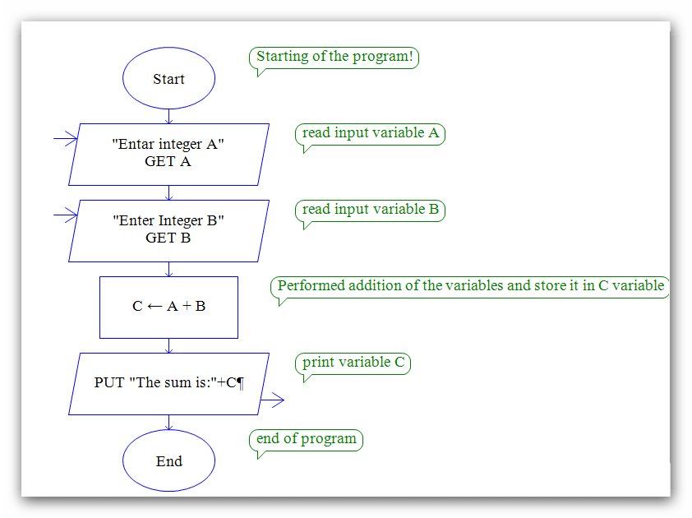

|  |  |  |  |  |  |  |  |
| --- | --- | --- | --- | --- | --- | --- | --- |
| **S.NO** | **DAY** | **10:00-11:00** | **11:00-12:00** | **12:00-1:00** | **1:00-1:30** | **1:30-2:30** | **2:30-3:30** |
| **1** | **MONDAY** | **PHYSICS** | **COMPUTER** | **CHEMEMISTRY** | **B** | **HINDI** | **ENGLISH** |
| **2** | **TUESDAY** | **MATHS** | **PHYSICS** | **COMPUTER** | **R** | **CHEMEMISTRY** | **HINDI** |
| **3** | **WEDNESDAY** | **ENGLISH** | **MATHS** | **PHYSICS** | **E** | **COMPUTER** | **CHEMEMISTRY** |
| **4** | **THURSDAY** | **HINDI** | **ENGLISH** | **MATHS** | **A** | **PHYSICS** | **COMPUTER** |
| **5** | **FRIDAY** | **CHEMEMISTRY** | **HINDI** | **ENGLISH** | **K** | **MATHS** | **PHYSICS** |
| **6** | **SATURDAY** | **COMPUTER** | **CHEMEMISTRY** | **HINDI** |  | **ENGLISH** | **MATHS** |

**14).Create a class time table using table option in ms word.**

**21).Write a c program to calculate area and circumference of circle.**

**CODING**

**#include<stdio.h>**

**#include<conio.h>**

**void main()**

**{**

**clrscr();**

**int rad;**

**float PI = 3.14, area, ci;**

**printf("\nEnter radius of circle: ");**

**scanf("%d", &rad);**

**area = PI * rad * rad;**

**printf("\nArea of circle : %f ", area);**

**ci = 2 * PI * rad;**

**printf("\nCircumference : %f ", ci);**

**getch();**

**}**

**OUTPUT**

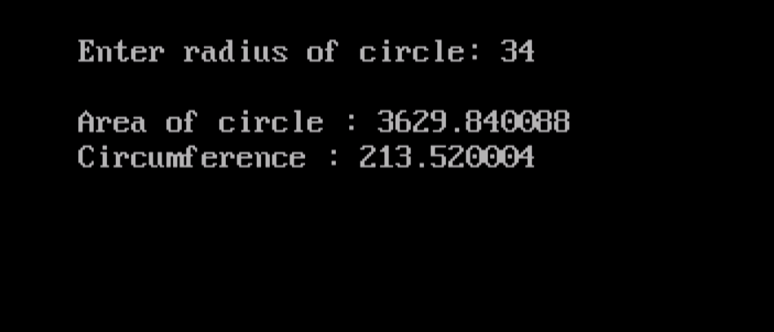

**22). write a c program to calculate addition subtraction multiplcation and division.**

**CODING**

**#include <stdio.h>**

**#include<conio.h>**

**void main()**

**{ clrscr();**

**int first, second, add, subtract, multiply;**

**float divide;**

**printf("Enter two integers\n");**

**scanf("%d%d", &first, &second);**

**add = first + second;**

**subtract = first - second;**

**multiply = first * second;**

**divide = first / (float)second; //typecasting**

**printf("Sum = %d\n", add);**

**printf("Difference = %d\n", subtract);**

**printf("Multiplication = %d\n", multiply);**

**printf("Division = %.2f\n", divide);**

**getch();**

**}**

**OUTPUT**

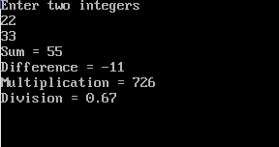

**23).** **Write c program to swap two numbers using third variable.**

**CODING**

**#include<stdio.h>**

**#include<conio.h>**

**int main()**

**{ clrscr();**

**int a, b;**

**printf("Input two integers (a & b) to swap\n");**

**scanf("%d%d", &a, &b);**

**a = a + b;**

**b = a - b;**

**a = a - b;**

**printf("a = %d\nb = %d\n",a,b);**

**getch();**

**}**

**OUTPUT**

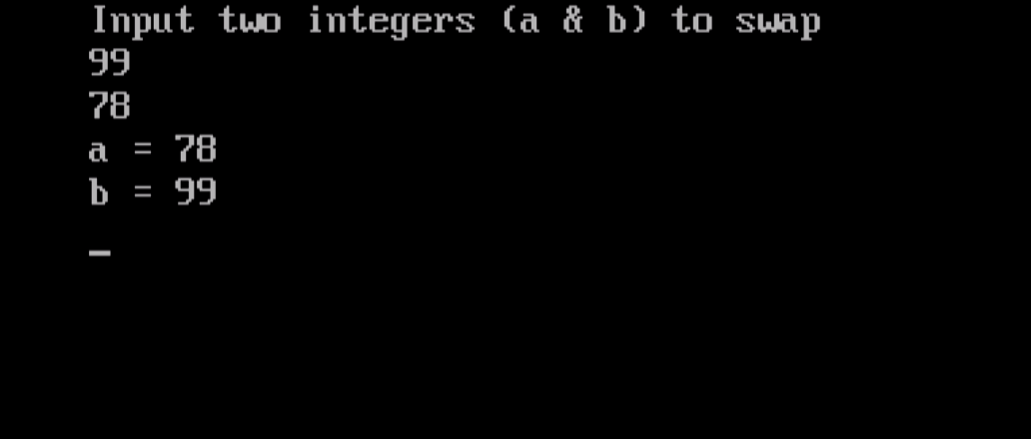

**24). Write c program to check no. even or odd.**

**CODING**

**#include<stdio.h>**

**#include<conio.h>**

**void main()**

**{**

**clrscr();**

**int n;**

**printf("Enter an integer\n");**

**scanf("%d", &n);**

**if (n%2 == 0)**

**printf("Even\n");**

**else**

**printf("Odd\n");**

**getch();**

**}**

**FIRST OUTPUT**

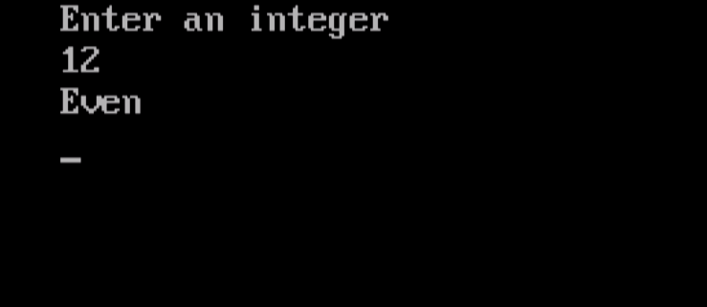

**SECONF OUTPUT**

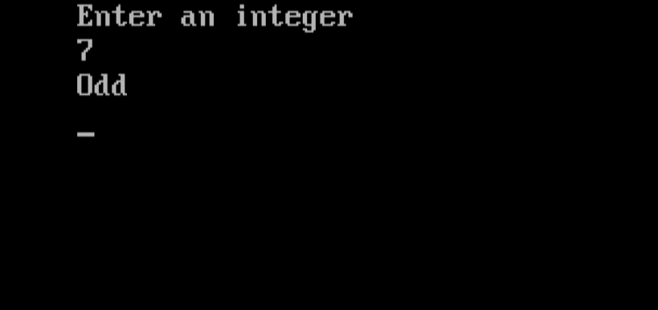

**25).** **Write c program to check greatest of 3 numbers.**

**CODING**

**OUTPUT**

**#include<stdio.h>**

**#include<conio.h>**

**void main()**

**{**

**clrscr();**

**int num1, num2, num3;**

**printf("Enter the values of num1, num2 and num3\n");**

**scanf("%d %d %d", &num1, &num2, &num3);**

**printf("num1 = %d\tnum2 = %d\tnum3 = %d\n", num1, num2, num3);**

**if (num1 > num2)**

**{**

**if (num1 > num3)**

**{**

**printf("num1 is the greatest among three \n");**

**}**

**else**

**{**

**printf("num3 is the greatest among three \n");**

**}**

**}**

**else if (num2 > num3)**

**printf("num2 is the greatest among three \n");**

**else**

**printf("num3 is the greatest among three \n");**

**getch();**

**}**

**OUTPUT**

